CSE 326: Report

**Project: Visit Bangladesh**

**Section: B2**

**Group no: 02**

**L3-T2**

**Group Members:**

Zarin Tasnim (1805071)

Fazle Alahi Mukim (1805083)

Prangon Chakraborty (1805085)

Sk Ruhul Azgor (1805091)

Md. Anowar Sharif Iqra (18050108)

Arif Faisal (18050118)

Date of Submission: 03 March, 2023

Motivation

● Customers can make their own tour plans and according to activities, regions as well as use the default packages.

● Contribution to the tourism industry.

Introduction

**Visit Bangladesh** is an online forum that brings everything about traveling at your fingertips. Using this platform, travelers all over the world can make their travel plans in Bangladesh, share their experiences, seek necessary information, and group up with people of shared interest to have an amazing traveling experience.

Requirement Analysis using BPMN diagram

The whole BPMN diagram:

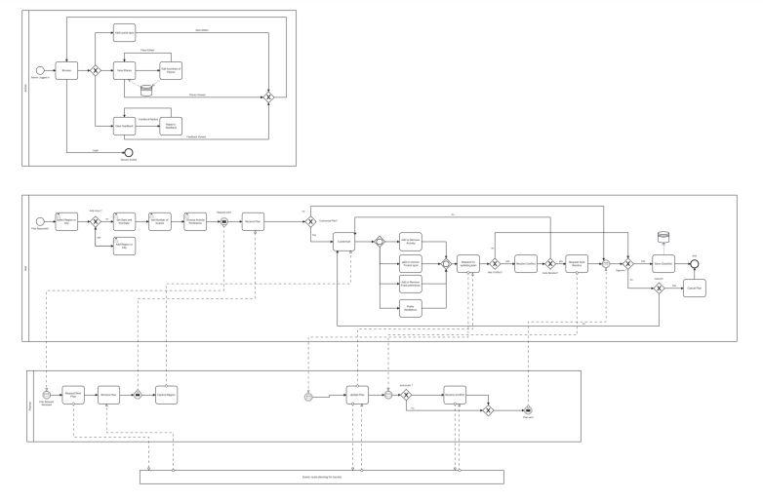

Admin:

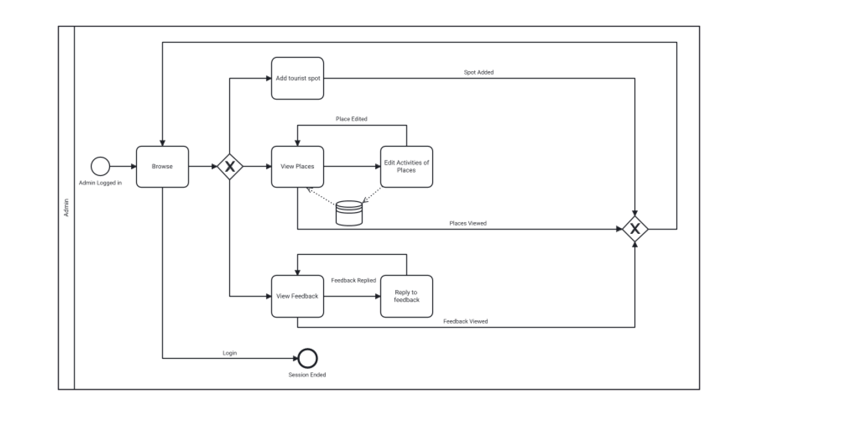

User: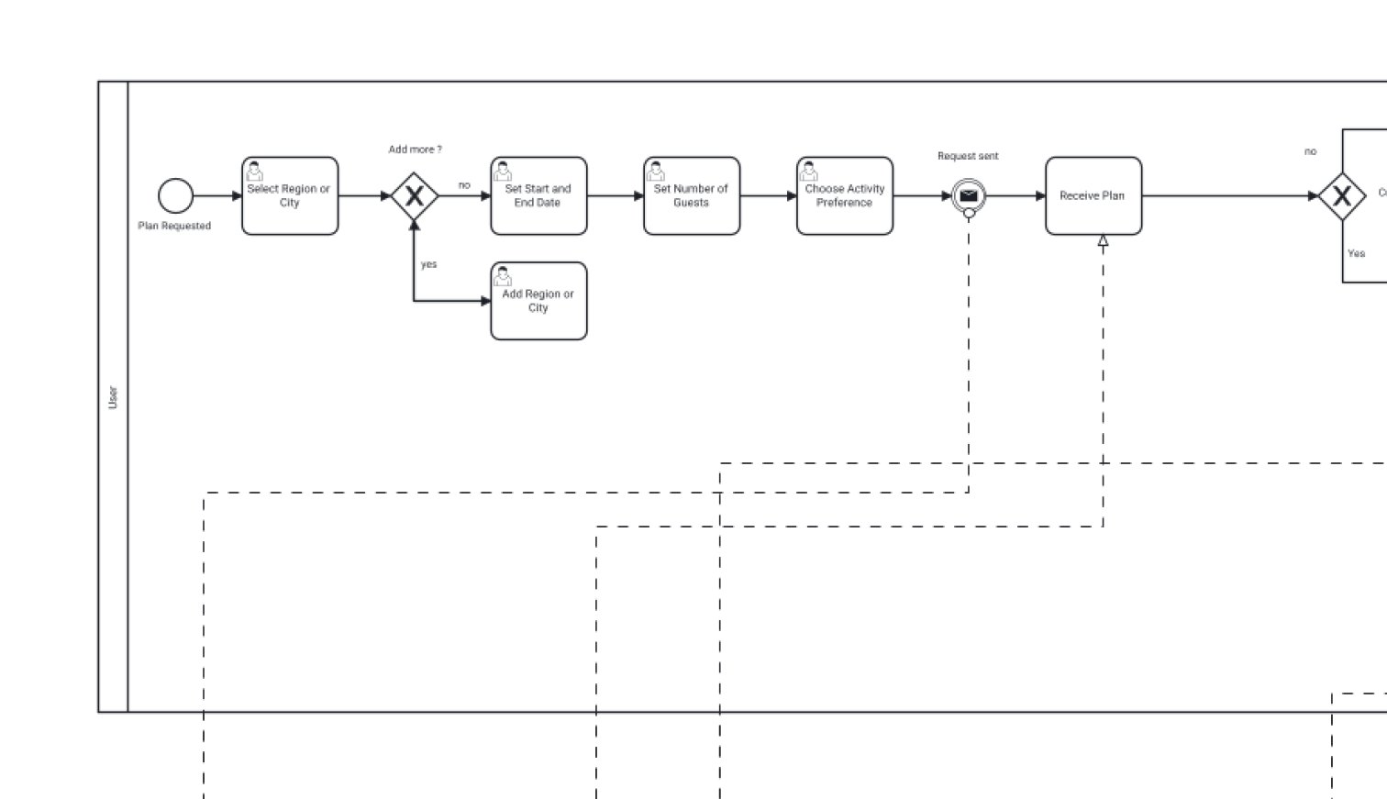

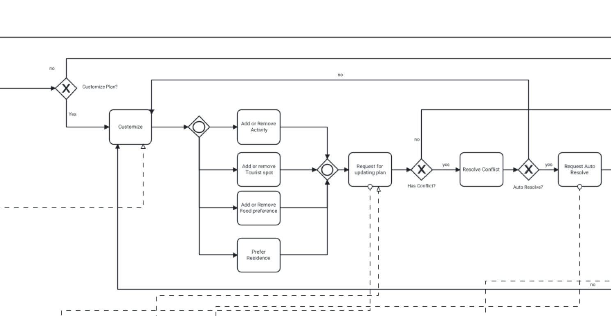

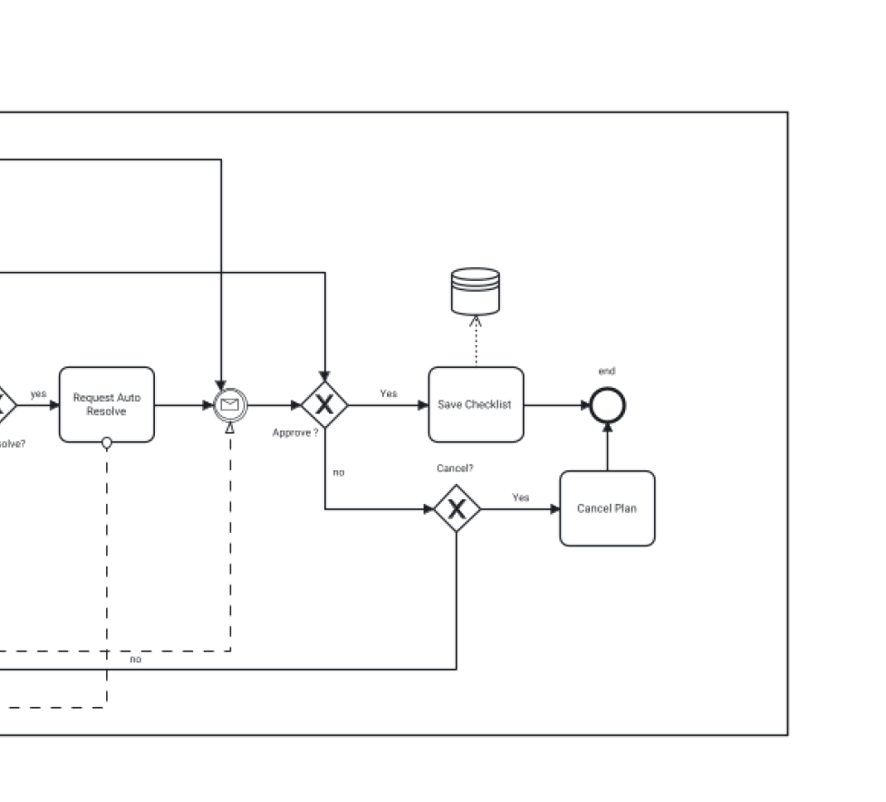

Planner:

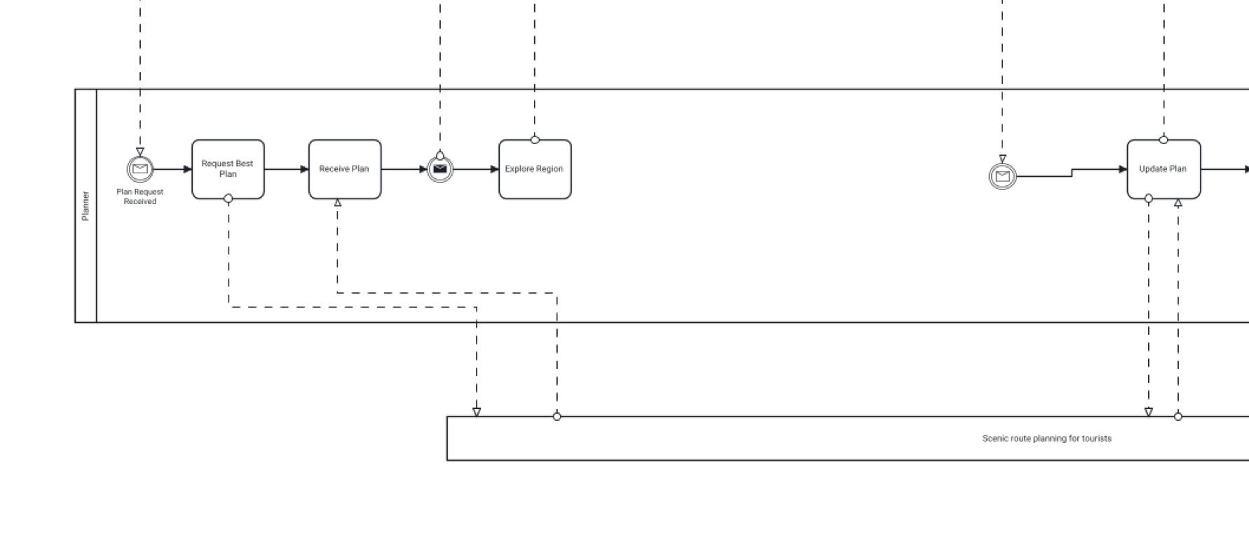

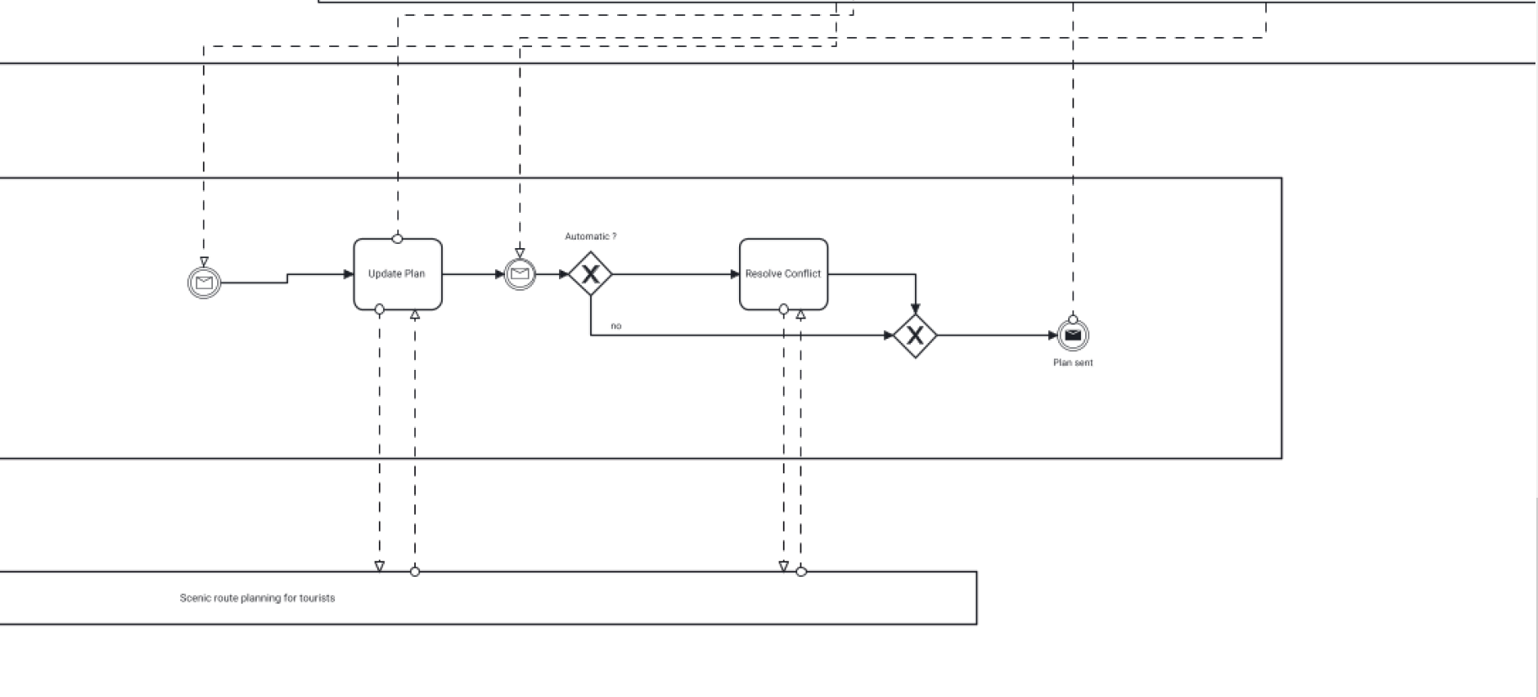

ER Diagrams

Full ER diagram:

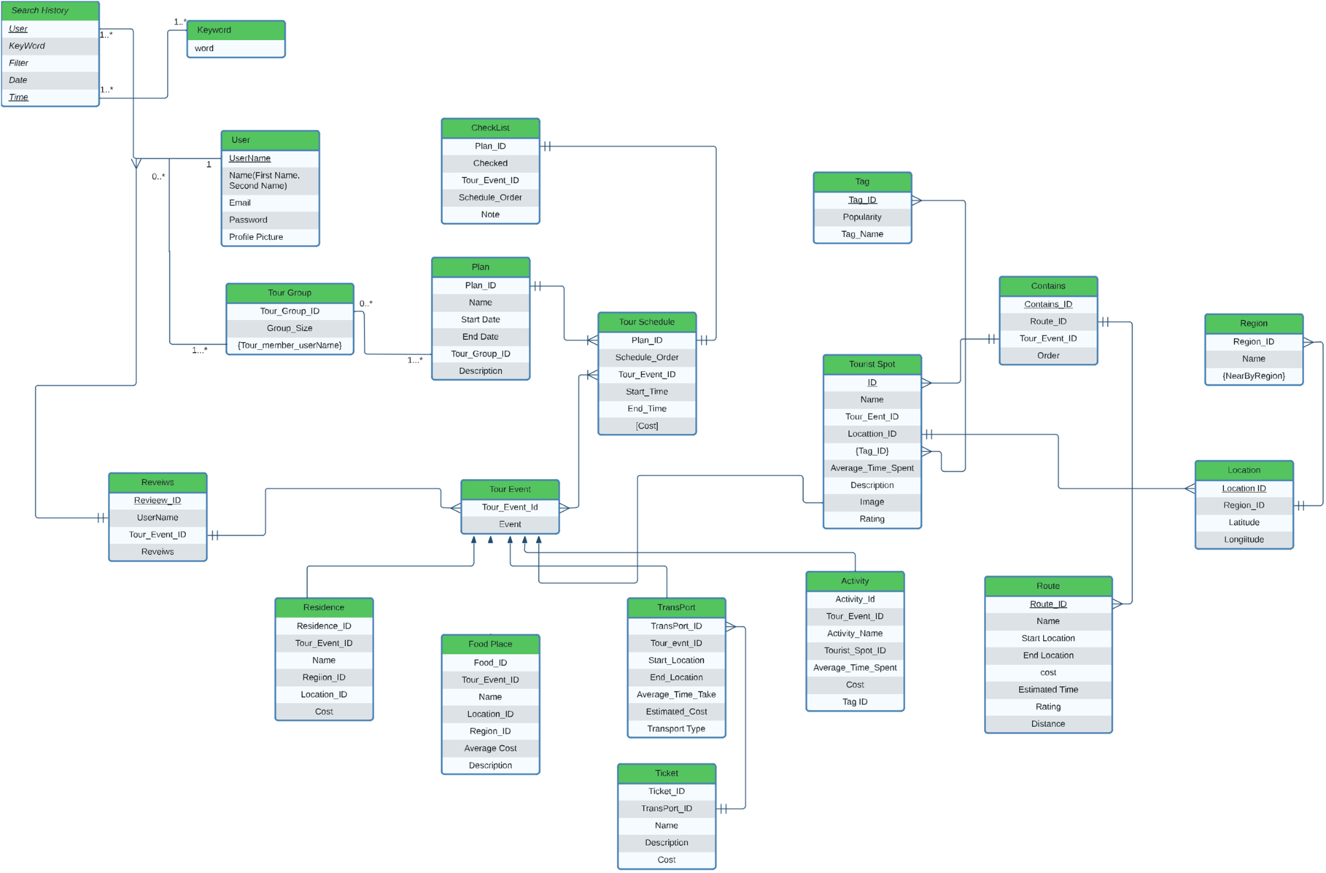

Class Diagrams

Info:

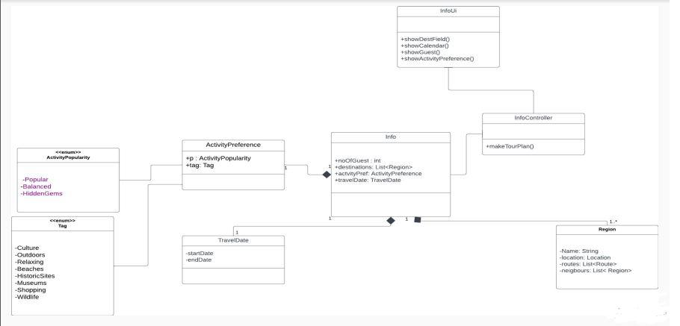

Make Plan:

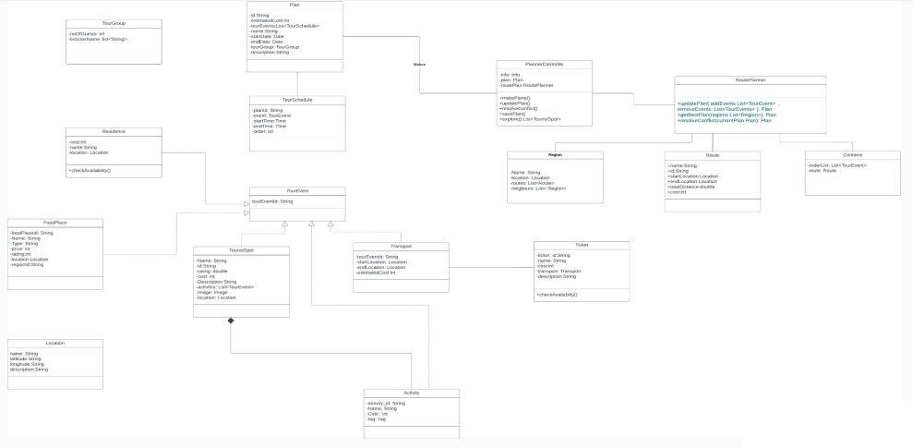

Search:

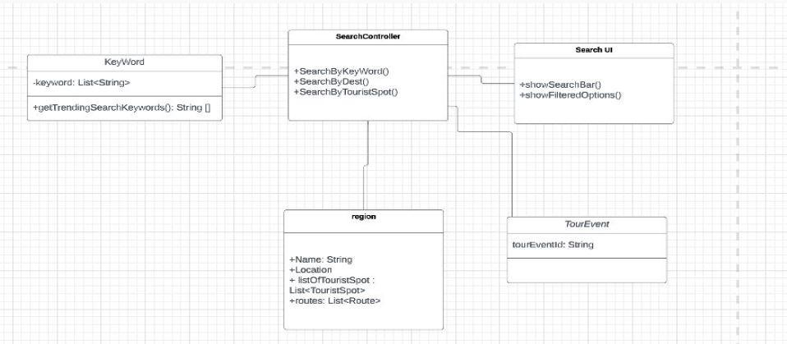

Edit Destination:

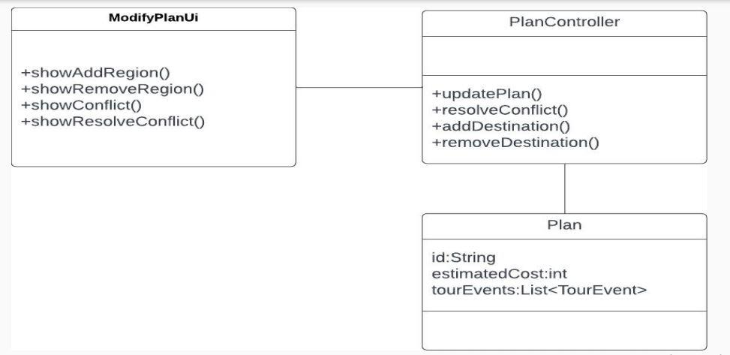

Explore:

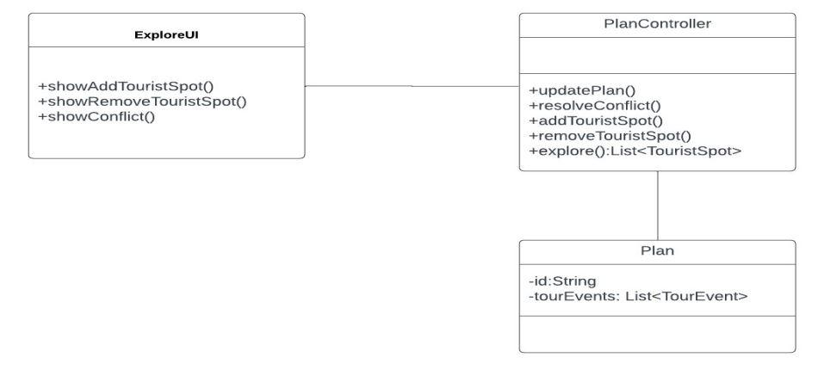

User Log In:

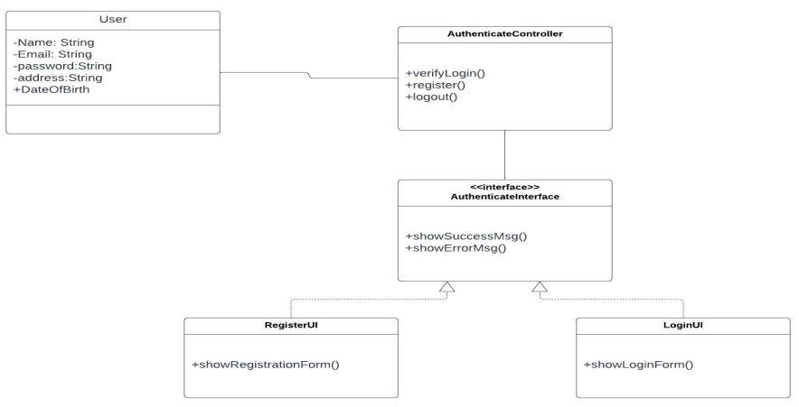

Review:

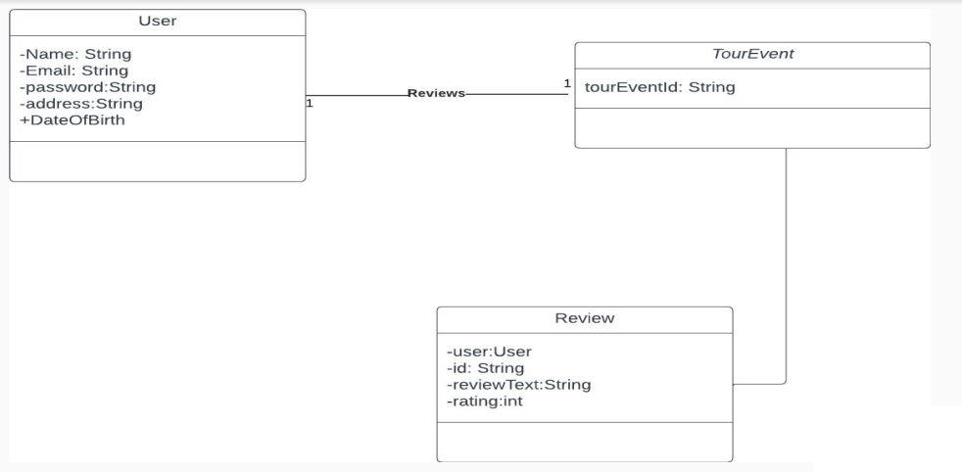

Checklist:

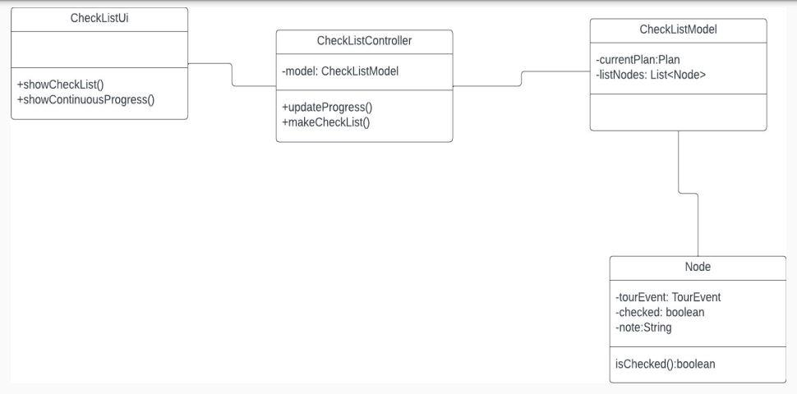

Collaboration Diagrams

InfoUI:

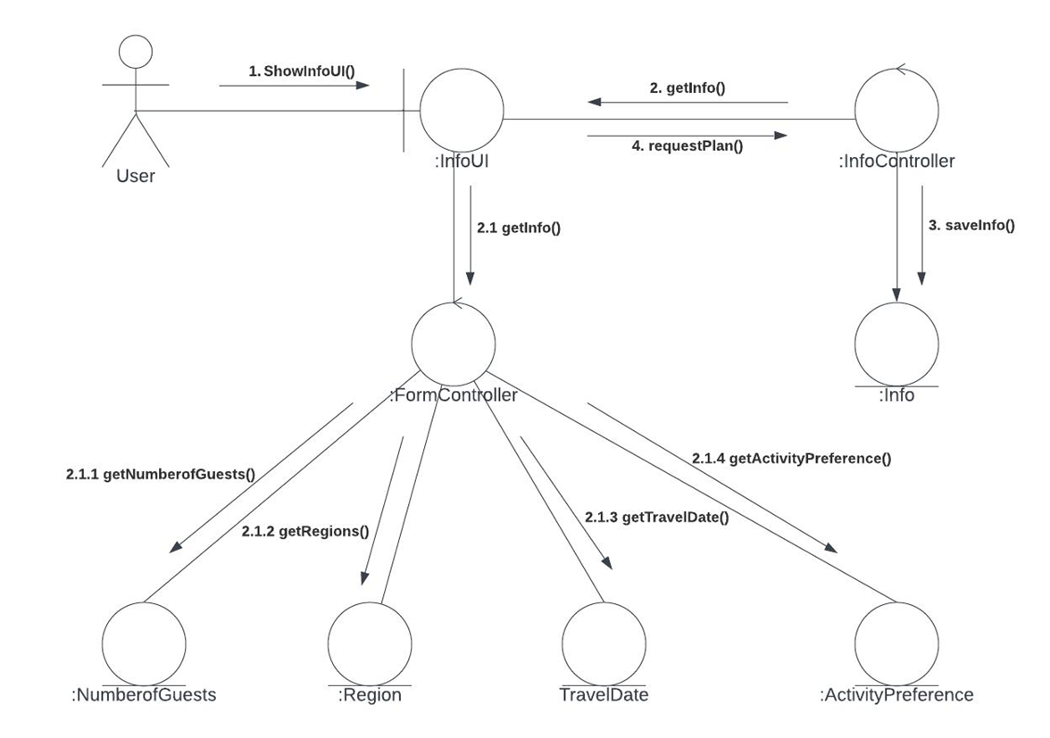

ExploreUI:

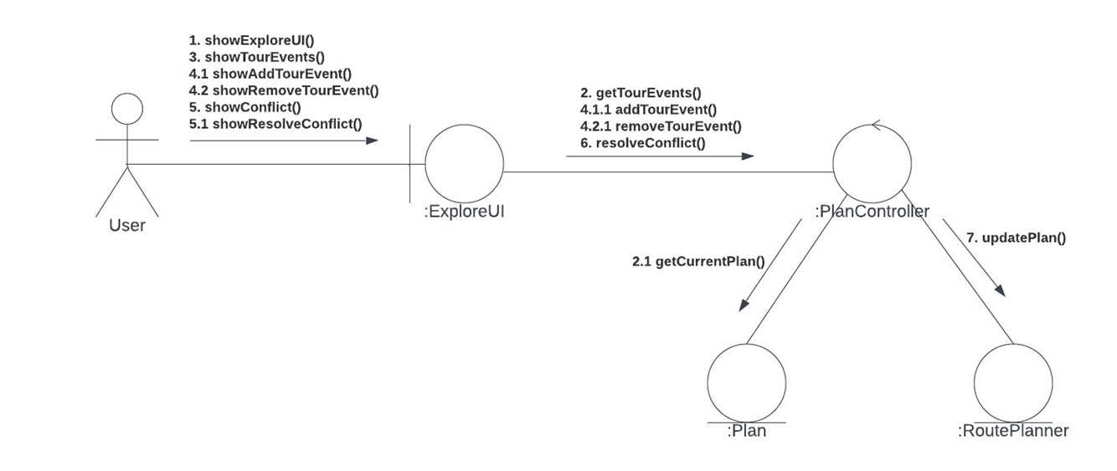

ModifyUI:

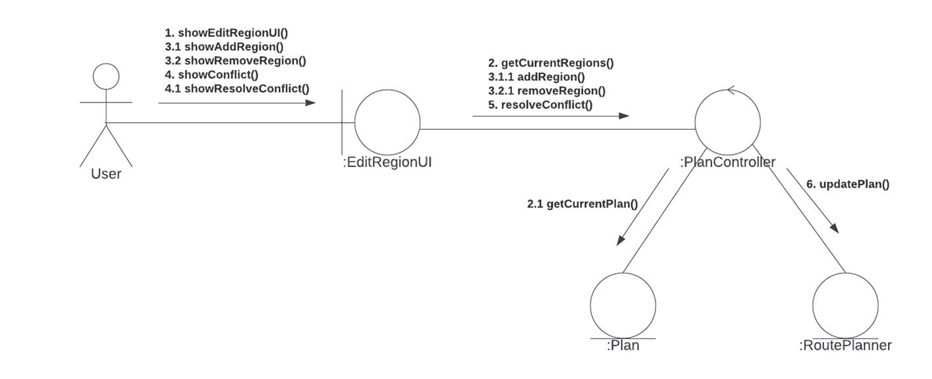

Make Plan:

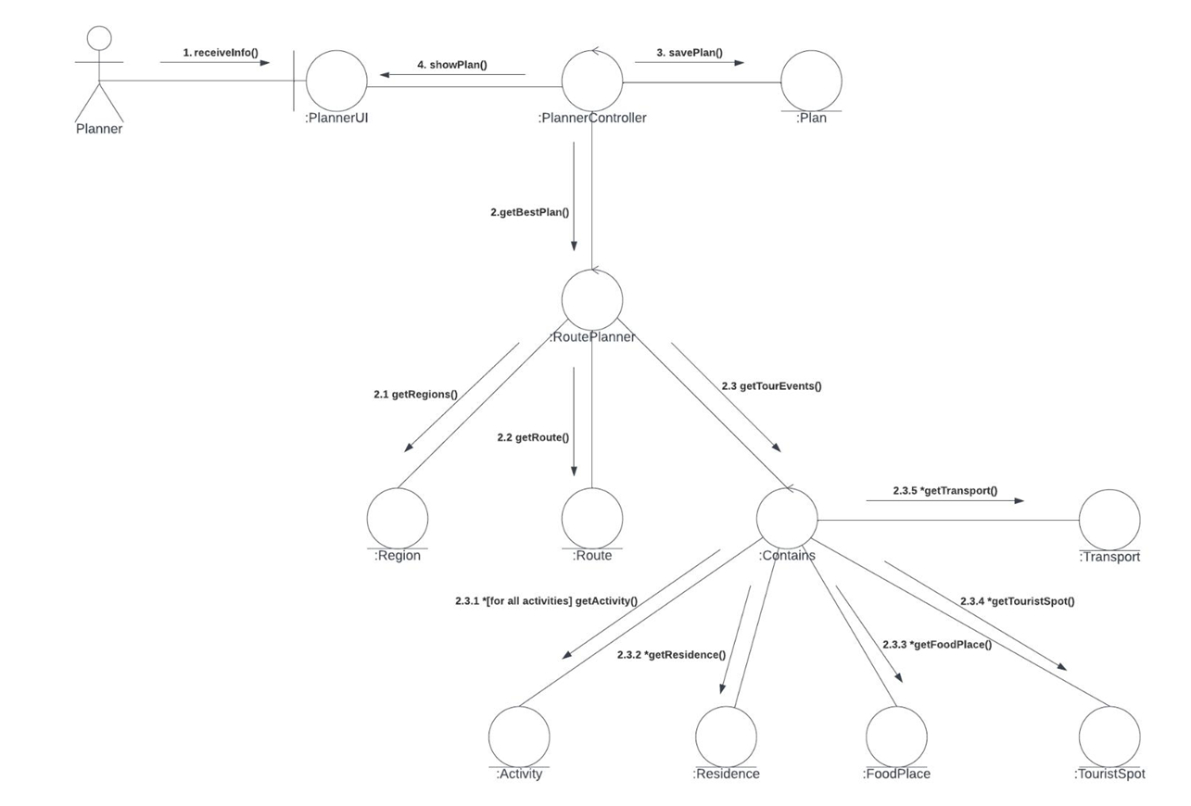

Checklist:

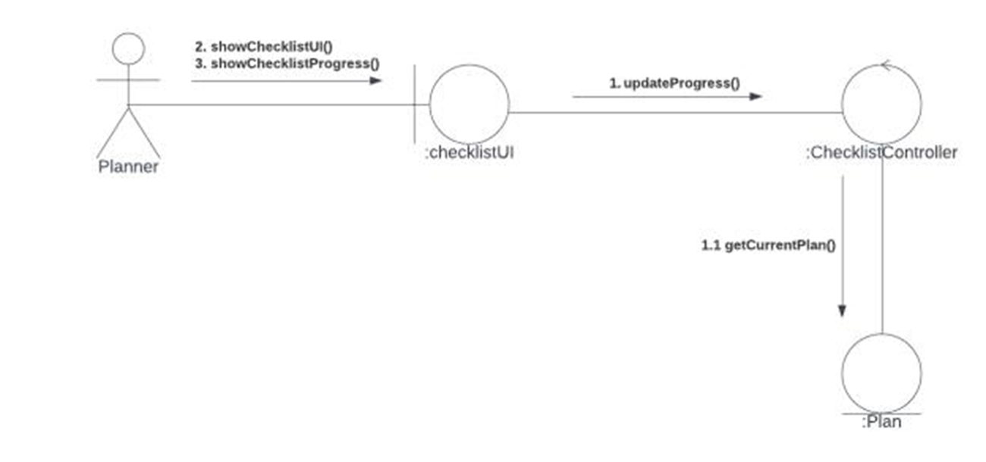

Review:

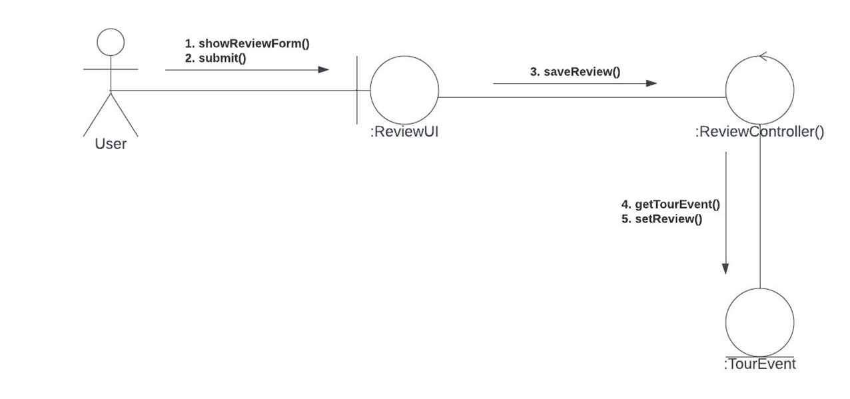

Search:

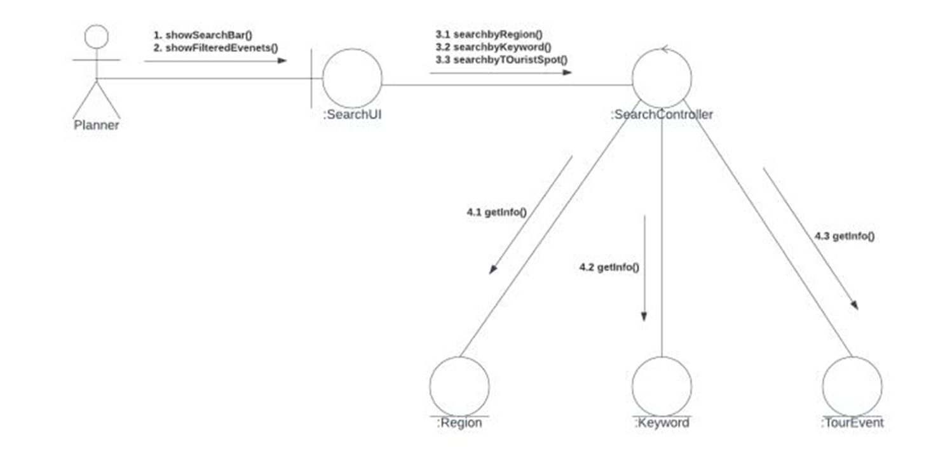

Sequence Diagrams

InfoUI:

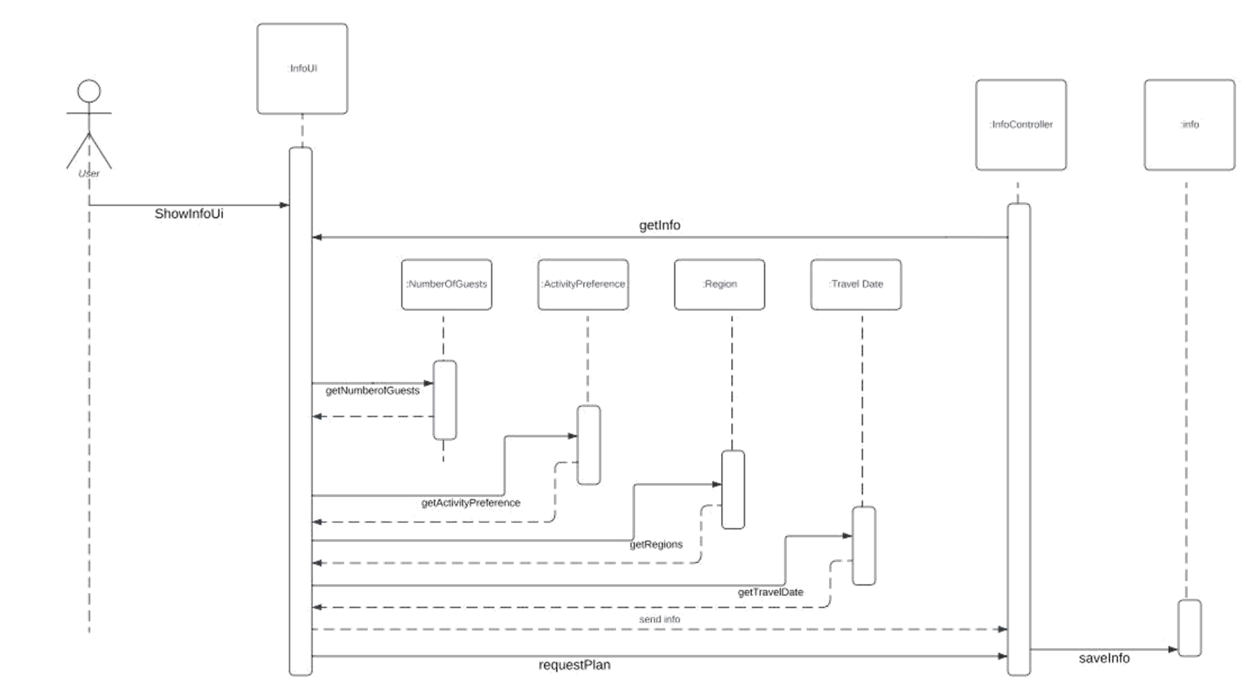

ExploreUI:

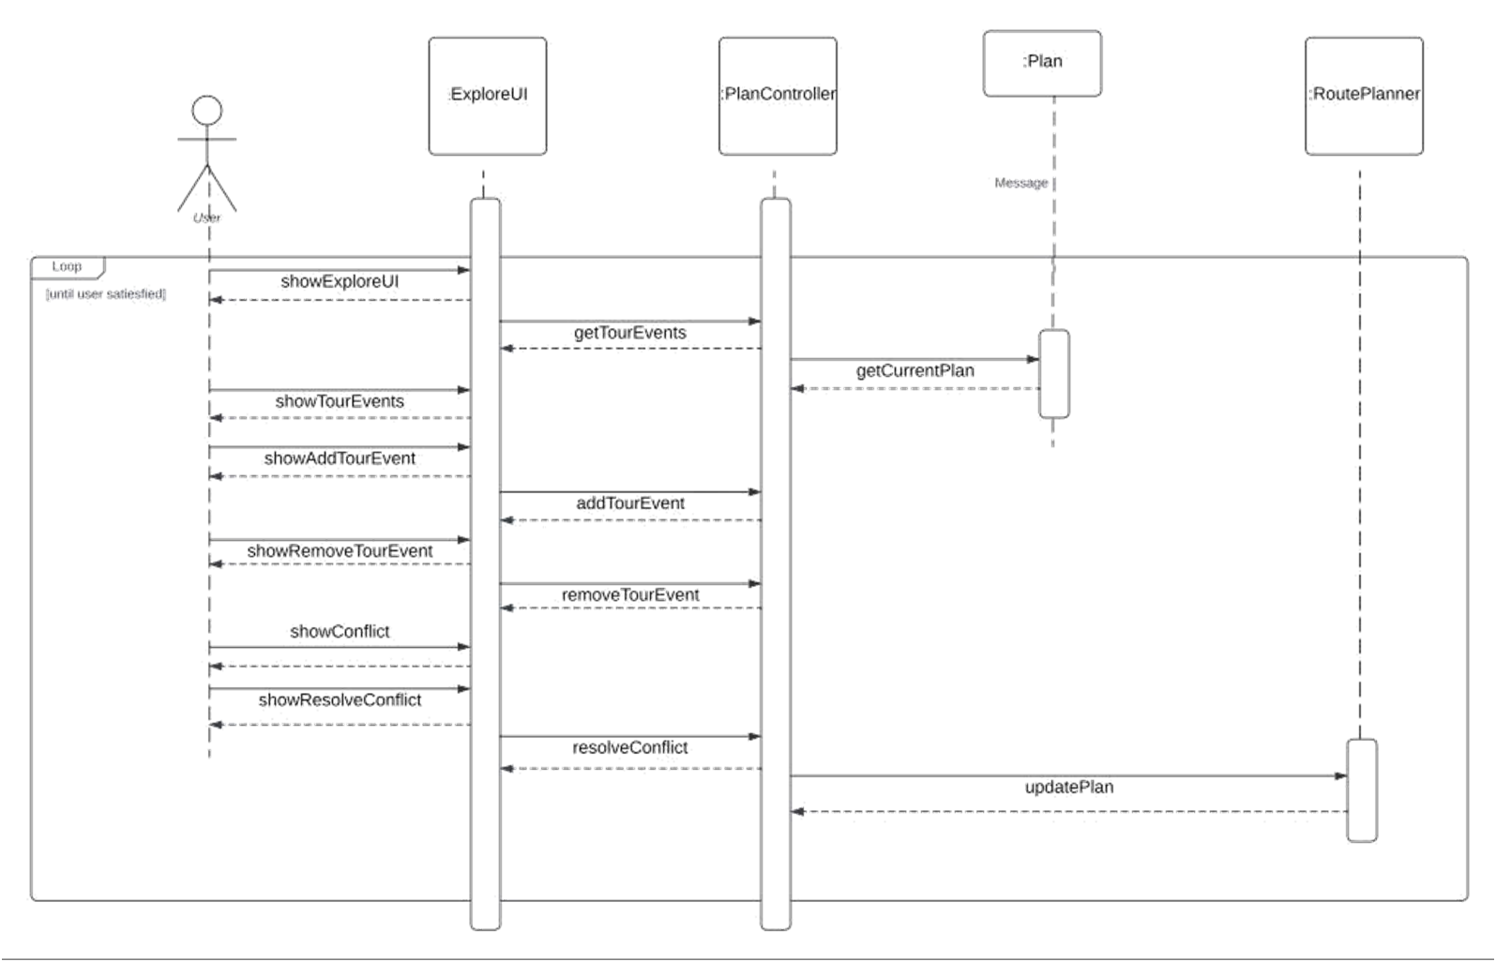

ModifyUI:

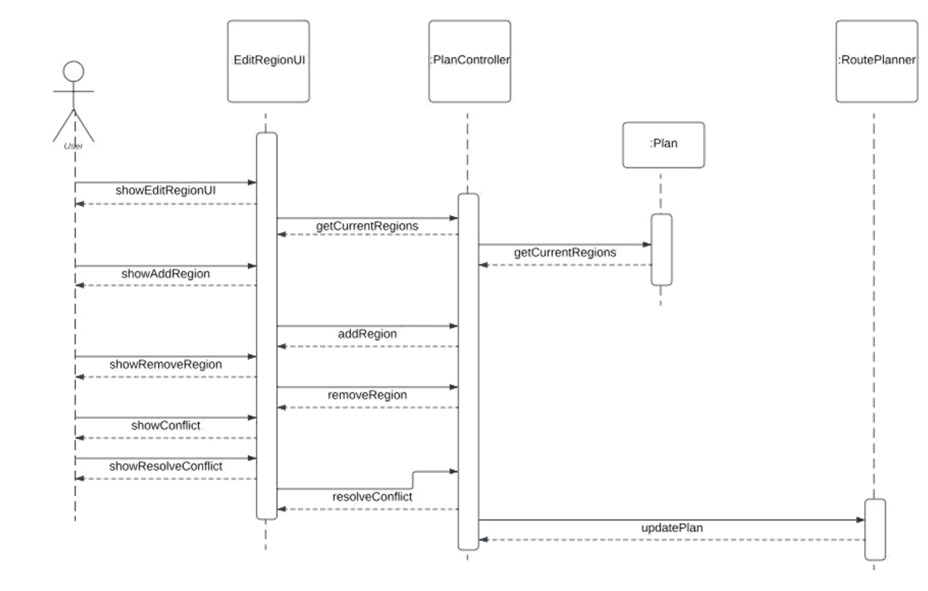

Make Plan:

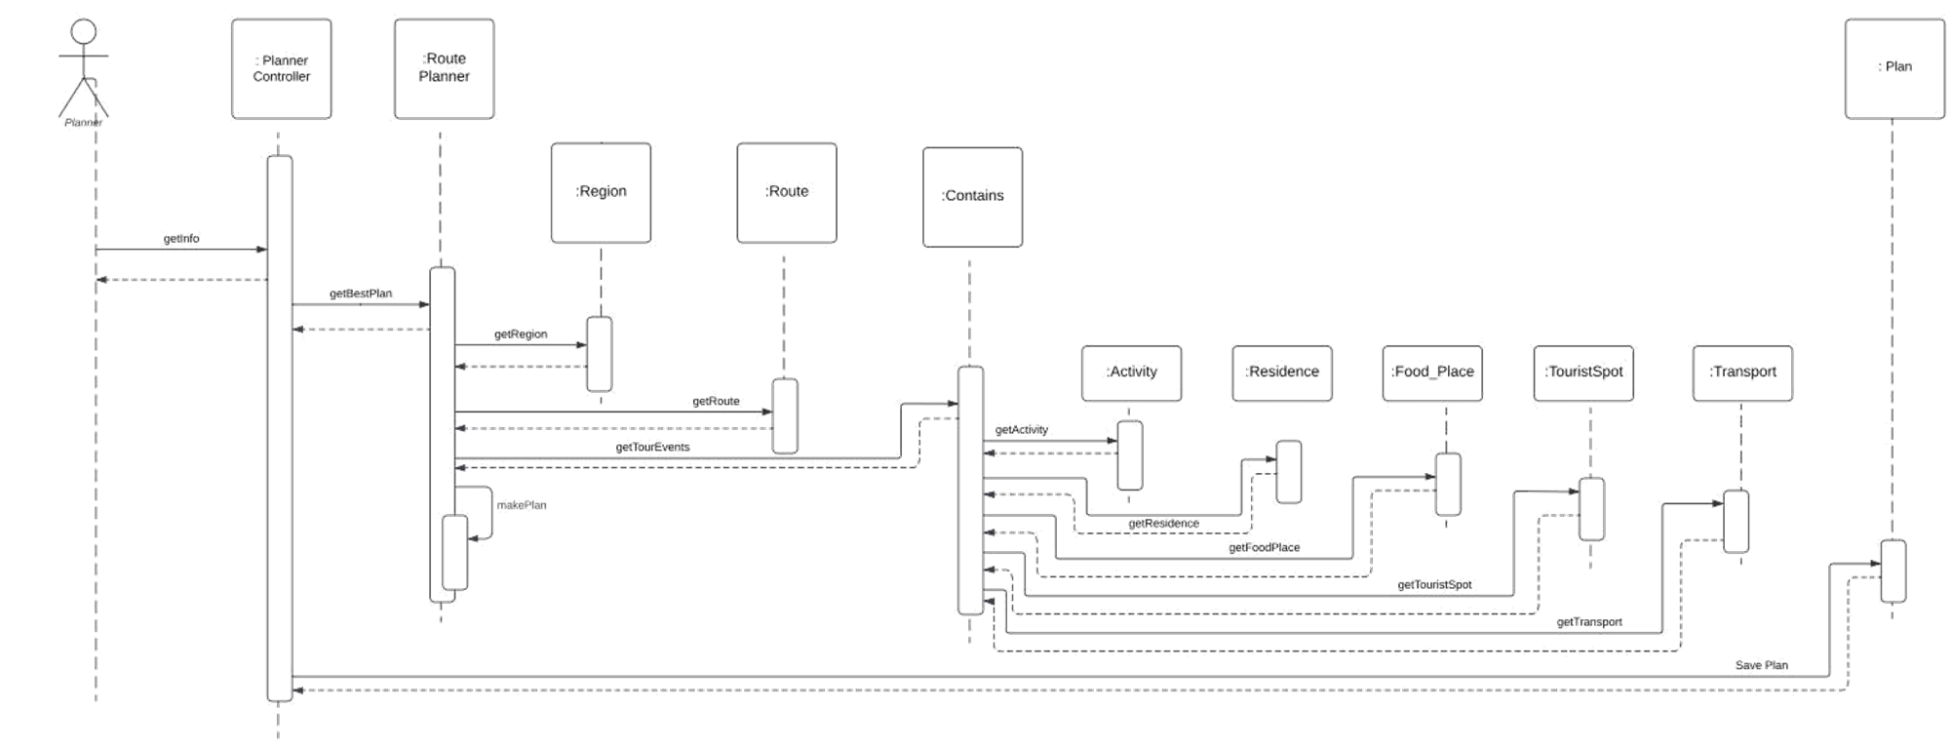

Checklist:

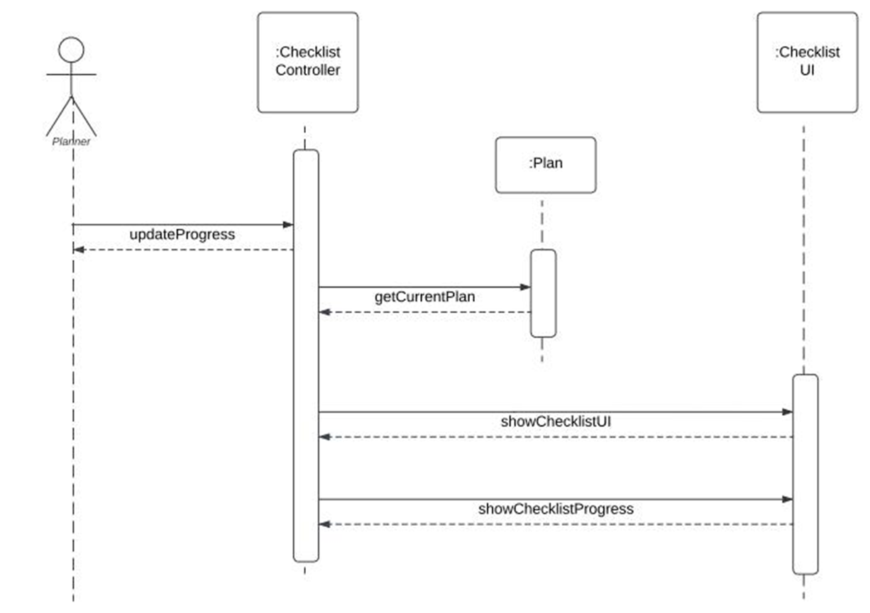

Review:

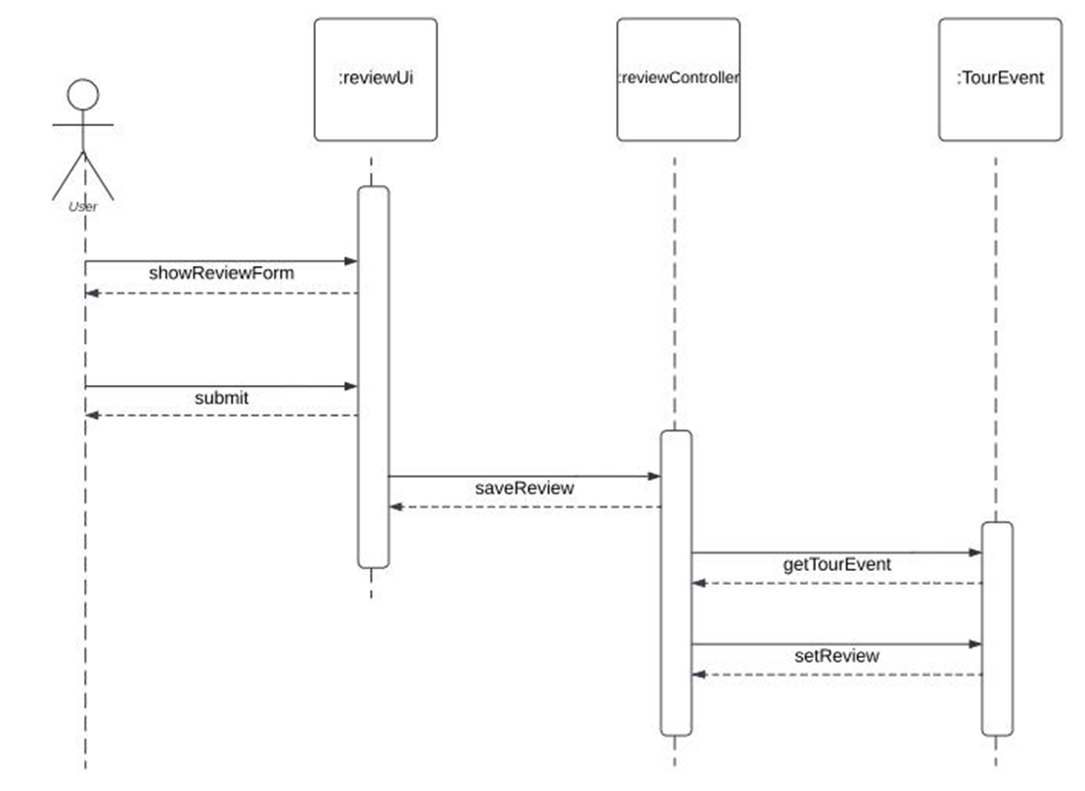

Search:

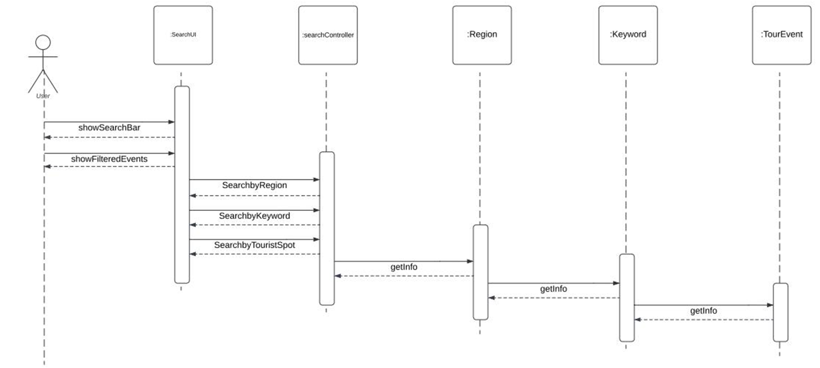

State Diagram

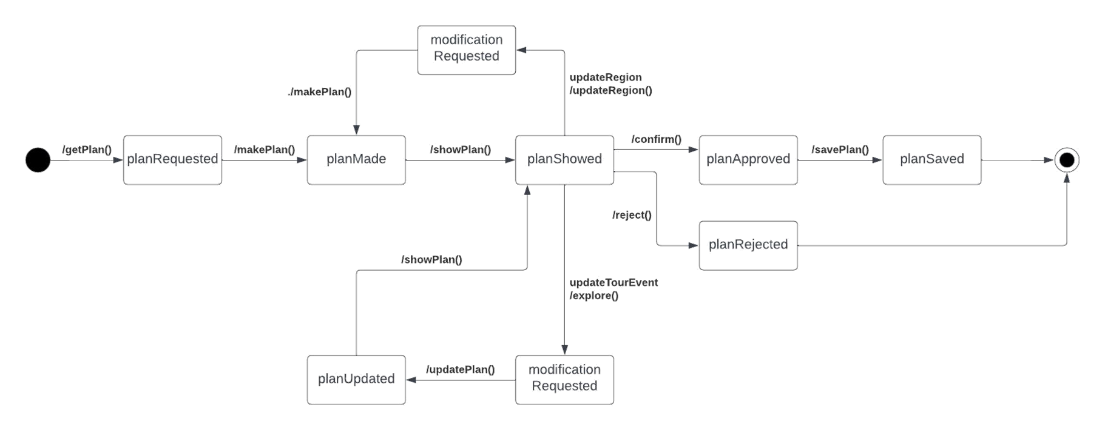

Mock UI

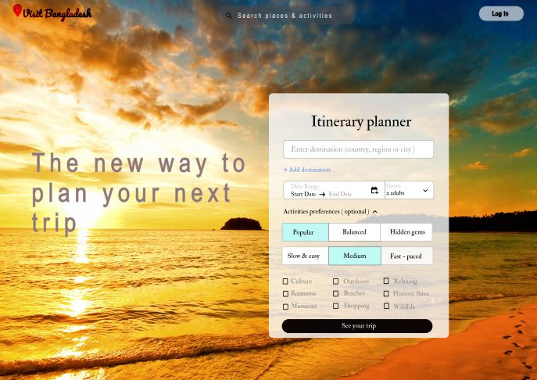



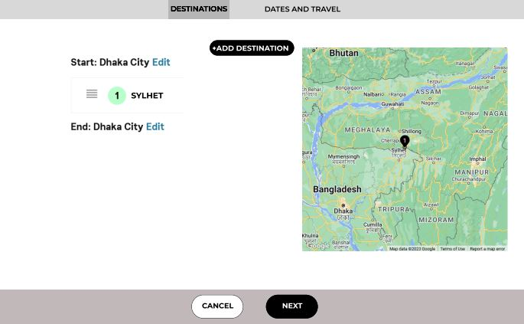

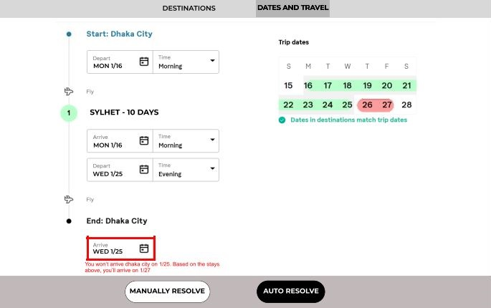

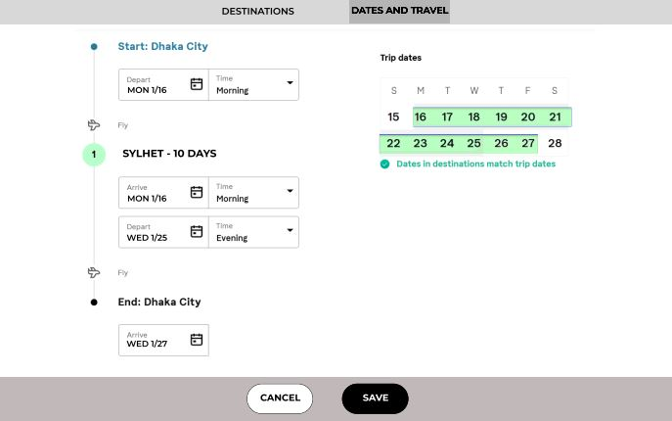



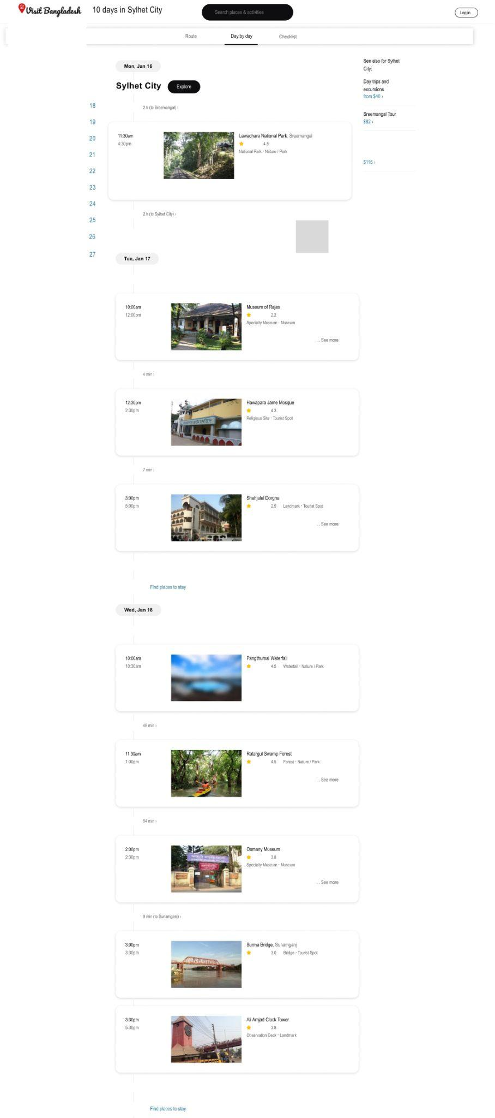

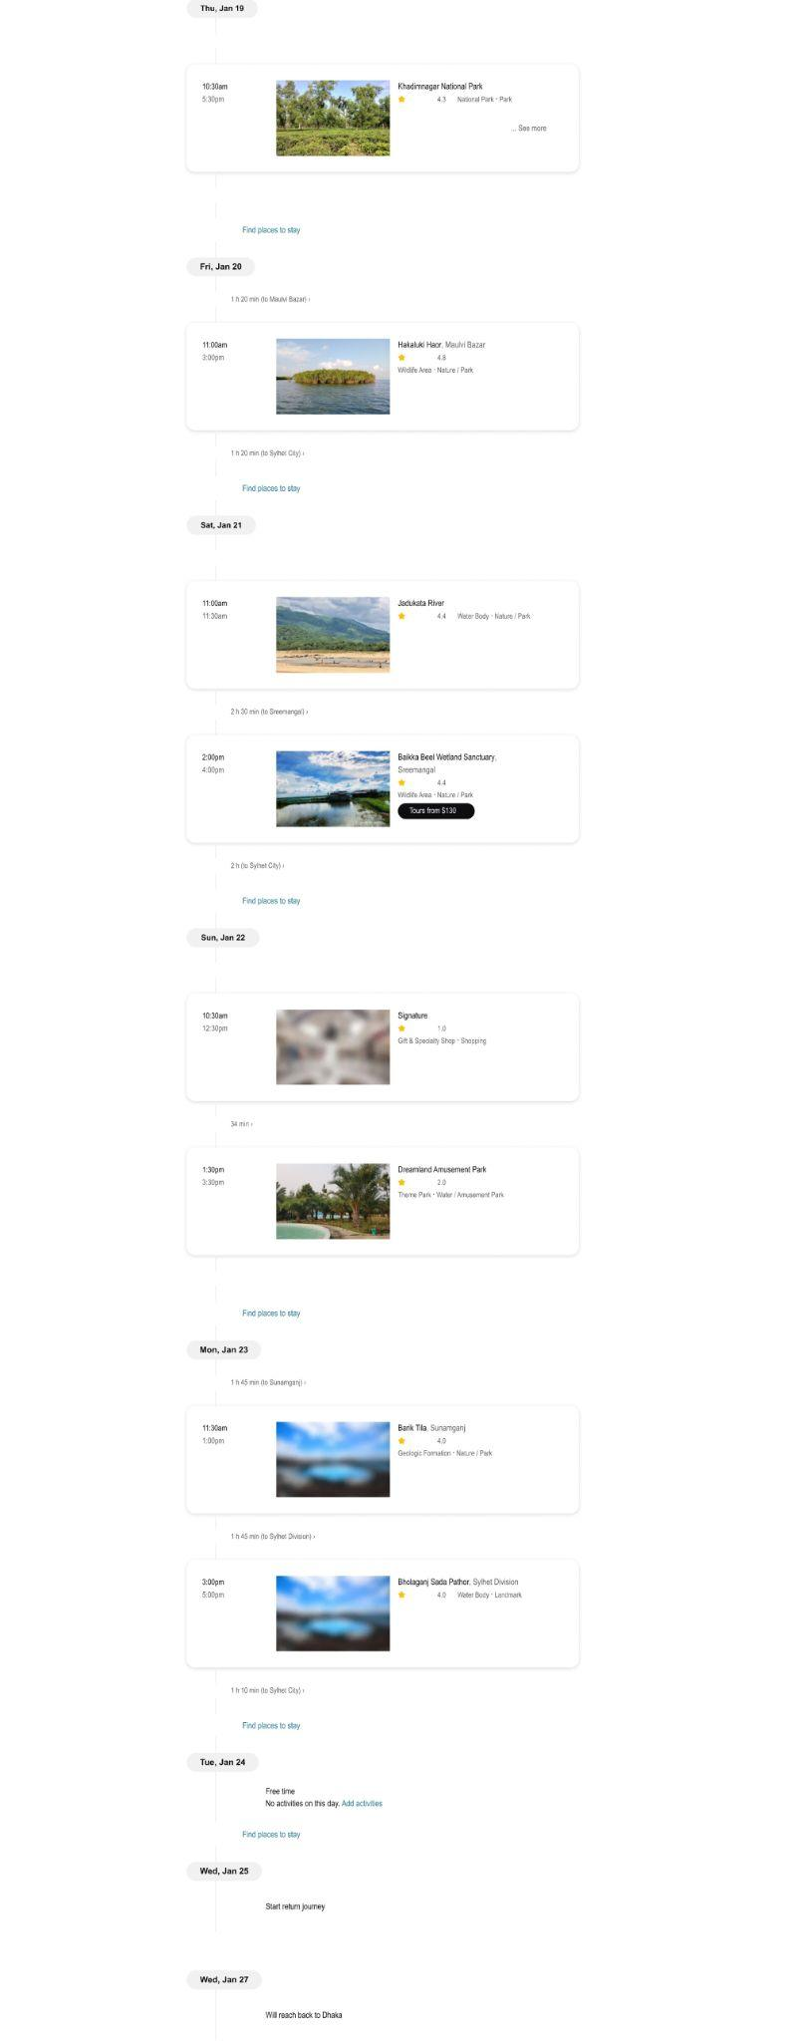





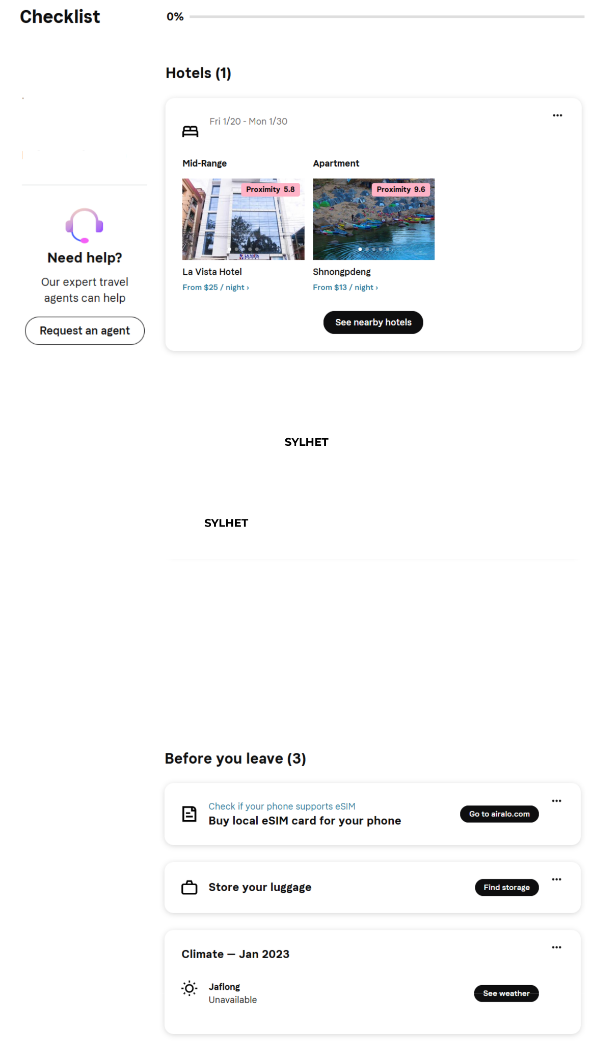











Implemented Module:

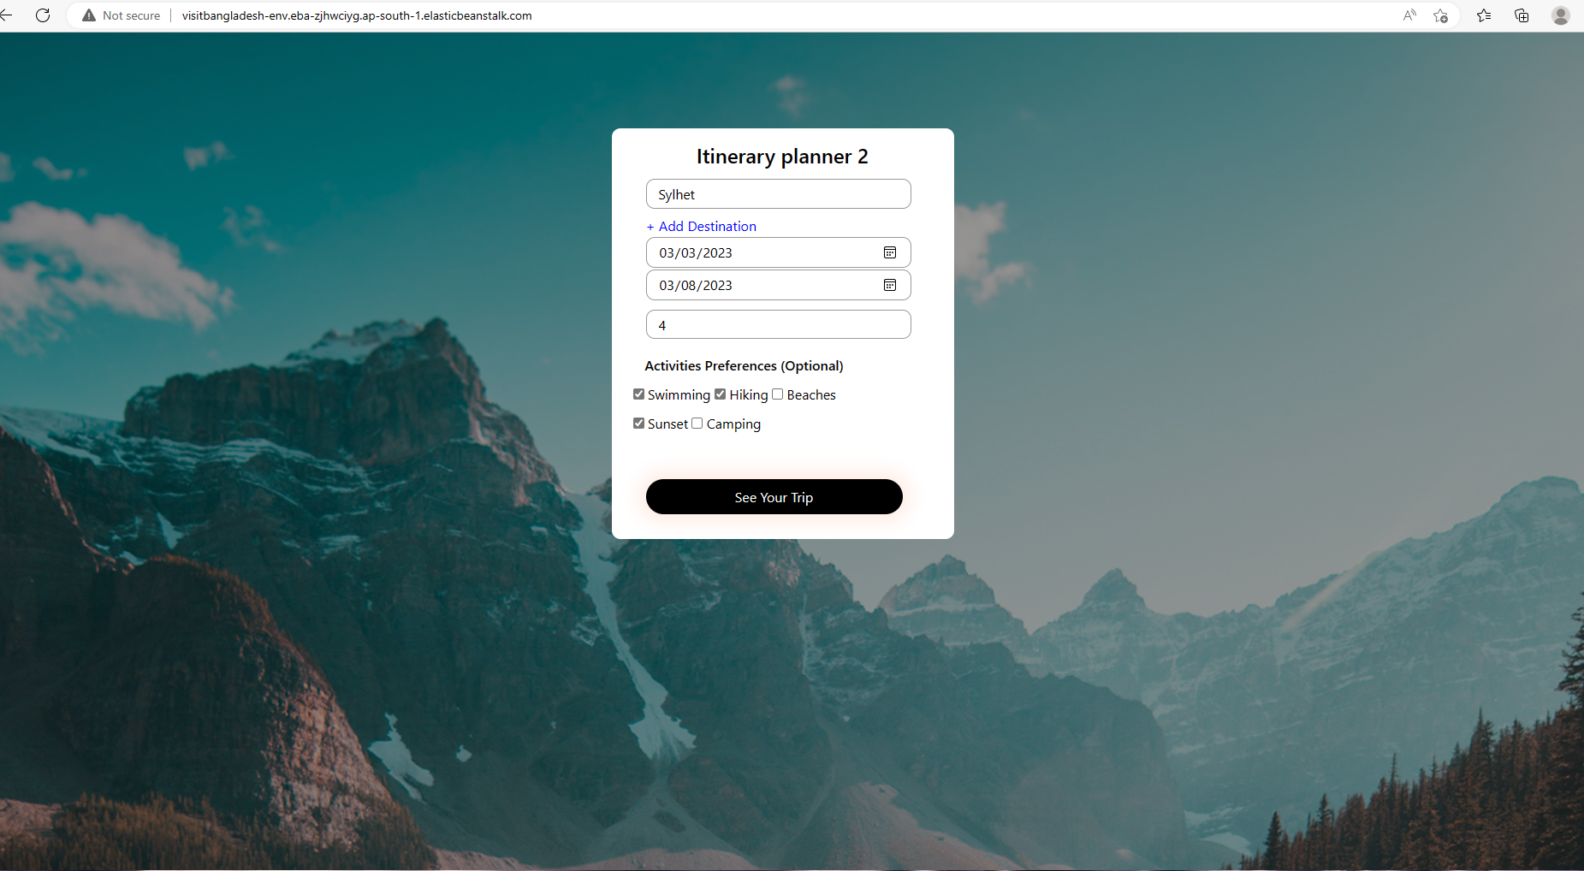

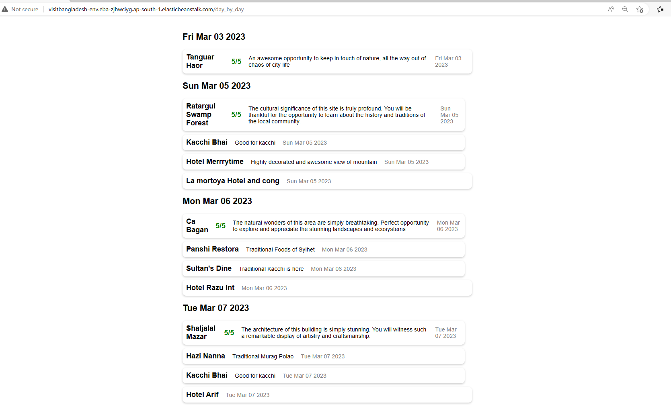

CI/CD Report:

Introduction:

The Continuous Integration/Continuous Deployment (CI/CD) process is a popular software development approach that helps to automate the software delivery process. This approach helps to improve the quality and speed of software delivery. In this report, we will discuss our CI/CD project in Elastic Beanstalk.

Project Description:

Our CI/CD project in Elastic Beanstalk was designed to deploy a web application automatically using a pipeline that includes Continuous Integration and Continuous Deployment stages. The web application is hosted on an Amazon Elastic Beanstalk environment. Elastic Beanstalk is an easy-to-use service for deploying and scaling web applications.

The project started with the development of the web application code. Once the code was ready, a GitHub repository was created to store the code.

Continuous Integration (CI) Stage:

The next step was to set up the Continuous Integration stage. This stage involved automatically building and testing the application code whenever changes were made to the code. To achieve this, AWS CodePipeline was used. CodePipeline is a fully-managed build service that compiles source code, runs tests, and produces software packages.

Continuous Deployment (CD) Stage:

After the code was successfully built and tested, the Continuous Deployment stage was initiated. This stage involved deploying the application to the Elastic Beanstalk environment automatically. AWS CodePipeline was used to automate this stage. CodePipeline is a fully-managed continuous delivery service that helps to automate the release process for our application.

Conclusion:

Our CI/CD project in Elastic Beanstalk was successfully implemented, and it has helped to improve the speed and quality of our software delivery. By automating the build, test, and deployment process, the project has reduced the time required to release new features, bug fixes, and updates. Overall, our project has demonstrated the value of implementing a CI/CD process in software development, and it has set the foundation for our future projects.

**Thank You!**